**1.** Create a NONGAME table with the structure shown in Figure 6-28.

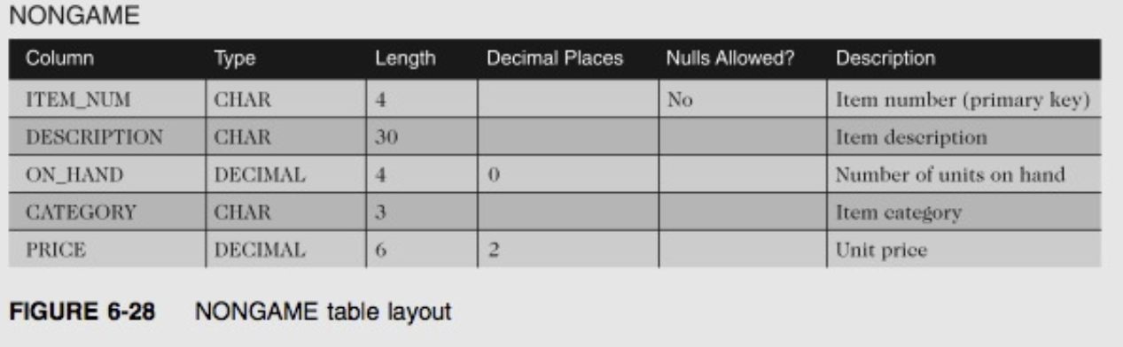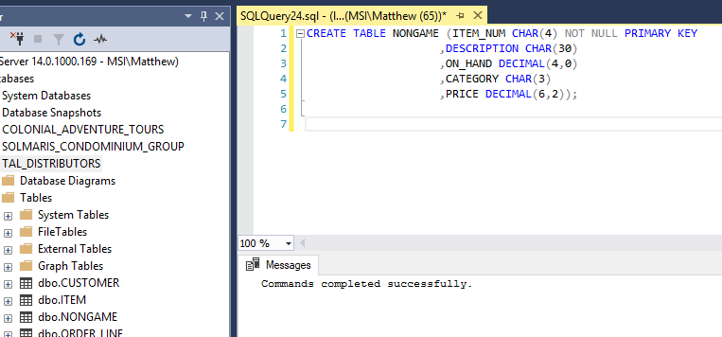

**2**.Insert into the NONGAME table the item number, description, number of units on hand, category, and unit price from the ITEM table for each item that is not in category GME. 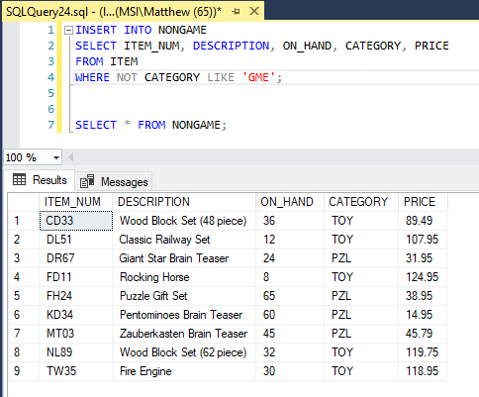

**3**. In the NONGAME table, change the description of item number DL51 to “Classic Train Set.” 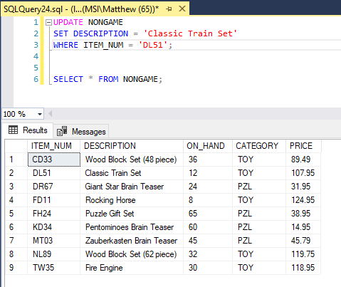

**4.** In the NONGAME table, increase the price of each item in category TOY by two percent. (Hint: Multiply each price by 1.02.) 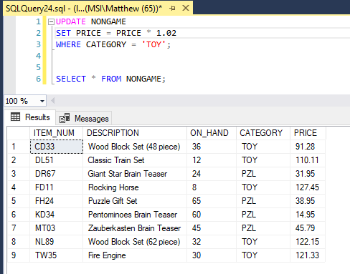

**5**. Add the following item to the NONGAME table: item number: TL92; description: Dump Truck; number of units on hand: 10; category: TOY; and price: 59.95. 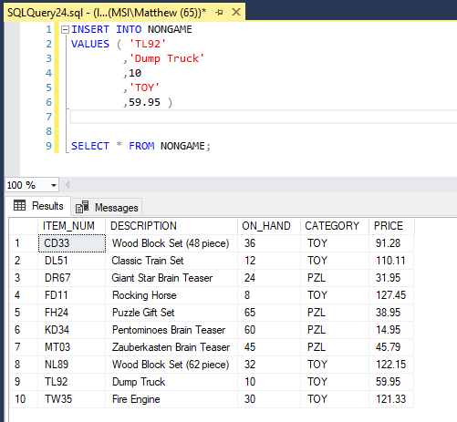

**6.** Delete every item in the NONGAME table for which the category is PZL. 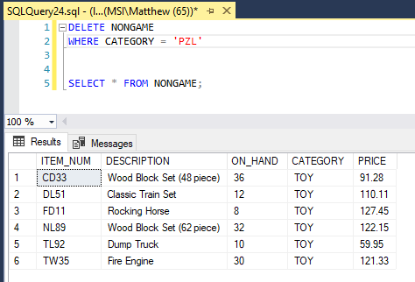

**7**. In the NONGAME table, change the category for item FD11 to null. 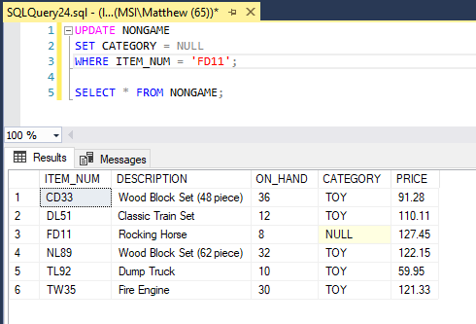

**8.** Add a column named ON_HAND_VALUE to the NONGAME table. The on-hand value is a seven-digit number with two decimal places that represents the product of the number of units on hand and the price. Then set all values of ON_HAND_VALUE to ON_HAND * PRICE. 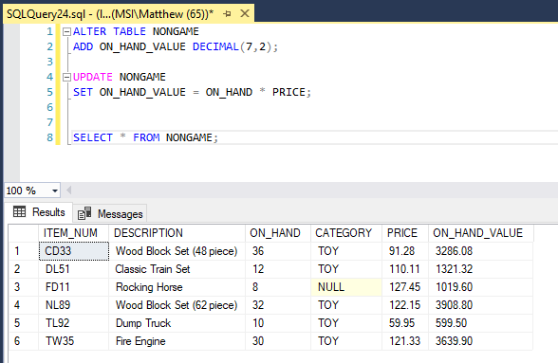

**9.** In the NONGAME table, increase the length of the DESCRIPTION column to 40 characters. 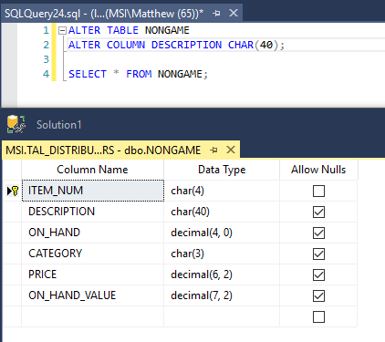

**10.** Remove the NONGAME table from the TAL Distributors database. 